Analytics, Interfaces, and Cloud Technology
Your Name
Professor’s Name
Course Title
Institution
Date

Introduction
Analytics has 6 important elements namely processing applications, data sources, computing power, analytic models, sharing/storage results, and data models. The implementation of either of the mentioned elements can be done as cloud analytics. Cloud computing is the new technology of these days since it economizes on resources hence lowering costs, it is very flexible, and it is very scalable.
- Support the need for the use of analytics and cloud technology within this company.
Analytics and cloud computing technology is an economical strategy that a company can use to cut down costs. The initial investment of cloud computing and analytics might be expensive but its maintenance costs are manageable considering that the technology saves much on costs. With cloud computing, virtualization is prime. The number of servers needed in a company is reduced hence freeing up space in the data centers. This will hence save a considerable amount of money on power and cooling. Another thing with cloud computing is that a data center based on the features of a cloud platform is developed (Khan et al., 2015). This is a strategy to save on the costs of data management while reducing bureaucratic procedures and unnecessary protocols within the entity at the same time. This makes service access very easy.
Customer need to be responded to in a timely and responsive manner. Cloud technologies and analytics are infrastructures that have given companies flexibility hence increasing agility. These days’ companies do not need to invest heavily on expensive infrastructures or rather buying software and hardware (Zulkernine et al., 2013). They invest on cloud computing which turns to be very economical. It would be easier, actually a couple of seconds for someone to access a certain system and meet up responsibilities. To the contrary, it would take days when someone has to share relevant information which needs to be acted upon immediately. In terms of marketing, a cloud based platform is very convenient to assemble products in the market in a faster way since the endorser will not need provisions of Information Technology like new servers and software.
It is important for companies to manage big data that has grown over the short past. Large corporations and institutions manages big data which needs to be properly analyzed to enhance company productivity. Not only does cloud computing give companies the privileges to improve on their analytical skills by storing their data in the cloud but also the provision of computing power that sifts via a large unstructured data (Bi, & Cochran, 2014). The provision also enables company’s administration to make sound decisions; achieve goals and propel forward. Cloud computing ensure that data is presented to the demands of the user in a way that is very easy to use. With cloud computing and analytics, the company is able to prepare for future growth in advance (Bi, & Cochran, 2014).
Cloud computing has made the development of software faster and tandem with existing demands of the market. In this case, the businesses that have their own internal software developers are positioned to achieve from economies of scale in software development as well as the implementation of cloud software (Khan et al., 2015). This means that the company is able and has the opportunity to standardize cloud architecture and by so doing implementing the cloud infrastructure hence making progress much faster as opposed to when in the mere traditional environments. Cloud computing makes software development so much faster (about 4 times) than the traditional platform. Database service among other services are also integrated into the system making it very convenient and effective. Documentation among other practices are fully established with cloud computing platform. I learnt that virtual machines and equipment tools can be installed into the platform. It provides for the testing of the machines and tools before implementation and the process is much time consuming as opposed to physical machines bearing in mind that they usually need reimaging every other time especially when a new update version is availed in to the market.
With the use of analytics and cloud computing, a company gets the right opportunity to make upgrades in a timely manner (Khan et al., 2015). Maintaining systems singly in an ordinary platform is somehow hectic and time consuming since security and other maintenance must be kept in time for better functioning of the entire system. Now you can imagine the challenge a huge company may be set to undergo if it has not adopted the cloud computing services, it can really be difficult. Cloud computing makes things much easier and faster. Companies with cloud computing services spend less time when updating servers and this makes them use that time in doing other constructive things that move the business ahead. Safety is assured with cloud computing services hence it is a service that secures company data in tandem with compliance of different business regimes. Cloud computing is a service that provides many extensions that yield to its economies of scale; for instance, it provides a high specialization that guarantees a high security level (Zulkernine et al., 2013). These platform also provides for continuous auditing, an extension that helps adjust necessarily hence increasing reliability since anything that is deviating is easily detected for immediate rectification.
Having talked of the cloud’s economies of scale, a company can be assured of carrying out much more business services through the same (Zulkernine et al., 2013). With many companies today thinking on how to increase their flexibility, the use of cloud computing and analytics is an excellent strategy. It helps manage risks and hence acting responsively toward the achievement of targeted aims. Its use is a way of increasing infrastructure redundancy in all aspects of the business. Business have the chance to expand easily given that the flexibility feature is availed which enables levels module addition to the company system.
Cloud computing is a technology that makes it possible for businesses to achieve better specified business goals in the corporate world and working for social responsibility. Having invested in data centers, cloud providers have a large scale. This is a way that economizes on resources and hence material waste given that less hardware is needed. This is a geared objective toward going green. Cloud computing and analytics makes business management an easy task given the virtual context that it utilizes, everything running on the company infrastructure is exhibited on a digitalized platform that allows management to identify any problems easily and quickly resolving them in good time (Zulkernine et al., 2013).
Work flow diagram
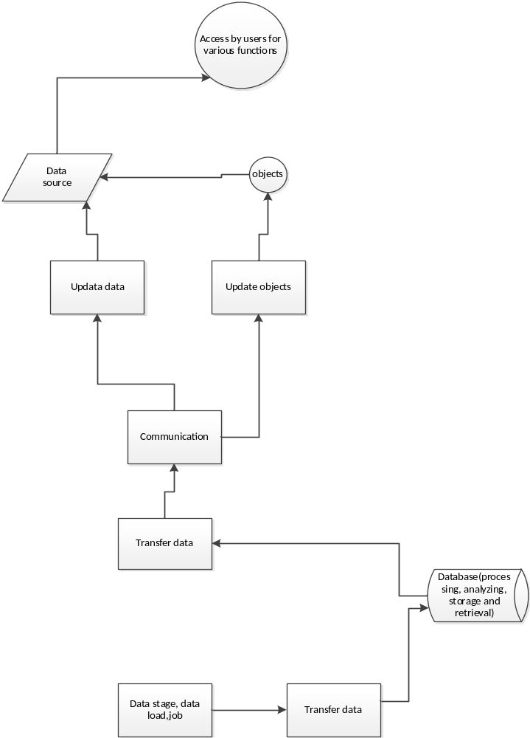

Screen layouts
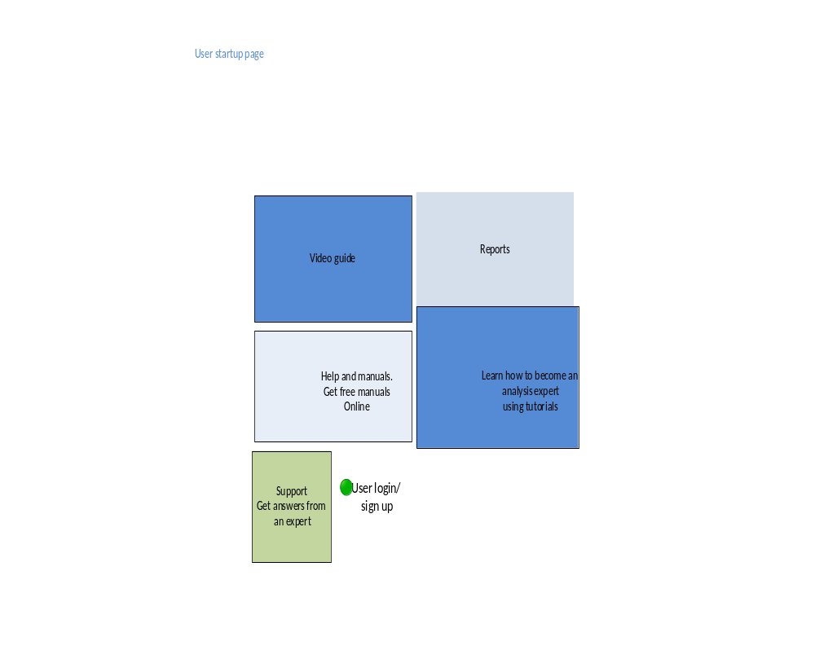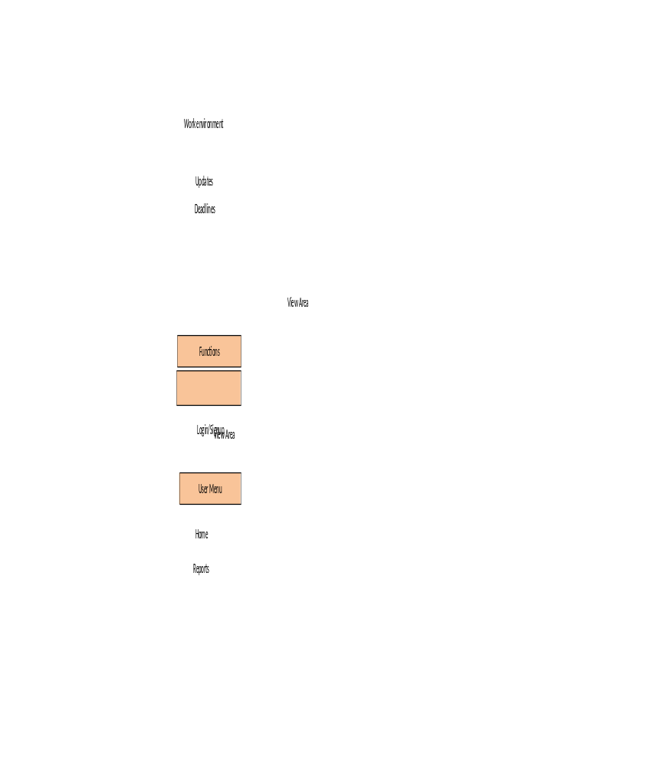
Conclusion
The use of analytics and cloud computing services is very ideal for a company that needs to work on its IT environment.
References
Bi, Z., & Cochran, D. (2014). Big data analytics with applications. Journal of Management Analytics, 1(4), 249-265.
Khan, Z., Anjum, A., Soomro, K., & Tahir, M. A. (2015). Towards cloud based big data analytics for smart future cities. Journal of Cloud Computing, 4(1), 2.
Zulkernine, F., Martin, P., Zou, Y., Bauer, M., Gwadry-Sridhar, F., & Aboulnaga, A. (2013, June). Towards cloud-based analytics-as-a-service (claaas) for big data analytics in the cloud. In 2013 IEEE International Congress on Big Data (pp. 62-69). IEEE.

